# F. Y. B. Tech Academic Year 2021-22

**Subject:** Basics of Electrical and Electronics Engineering **Trimester: I**

**Name:** Shreerang Mhatre **Division:** **11**

**Roll No:** 111056 **Batch:** **K3**

# Experiment No: 4

**Name of the Experiment**: Measurement of transistor amplifier gain in CE configuration

**Performed on: 07/01/2022**

**Submitted on: 14/01/2022**

**Aim:** Measurement of transistor amplifier gain in Common Emitter (CE) configuration

# Prerequisite:

* Working of transistor and its CE characteristics
* Transistor as an amplifier

# Objective:

* To measure the input and output voltages and observe the waveforms at the input and output terminals of a single stage common emitter amplifier circuit
* To calculate voltage gain of the amplifier

# Components and equipment required:

Transistor BC547, resistors, capacitors, function generator, connecting probes and CRO etc.

# Theory:

**Data sheet specification of transistor BC547:**

The transistor is a three terminal device which consists of two P-N junctions. Its main utility lies in the ability to amplify weak signals. Some passive components like resistors, capacitors and biasing supply are connected to transistors to form a circuit called an amplifier. Thus, an amplifier is an electronic circuit which is capable of amplifying or increasing the level of signals.

The BC547 is an NPN epitaxial silicon transistor. The BC547 transistor is a general- purpose transistor available in small plastic packages. It is used in general-purpose switching and amplification applications. Fig. 4.1 indicates symbol and pin out diagram of BC 547. Data sheet specifications of BC 547 are given in Table 4.1. The information

provided by the data sheet is useful to analyse or design a transistor circuit. In this experiment, a transistor is used in small signal audio amplifier and hence following are important set of data obtained from the datasheet:

1. Maximum allowable collector-base voltage, 2. Current gain *β*

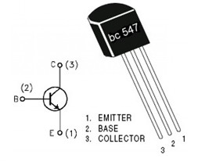

**Fig 4.1: Pin out of BC 547**

**TABLE 4.1: Data sheet specifications**

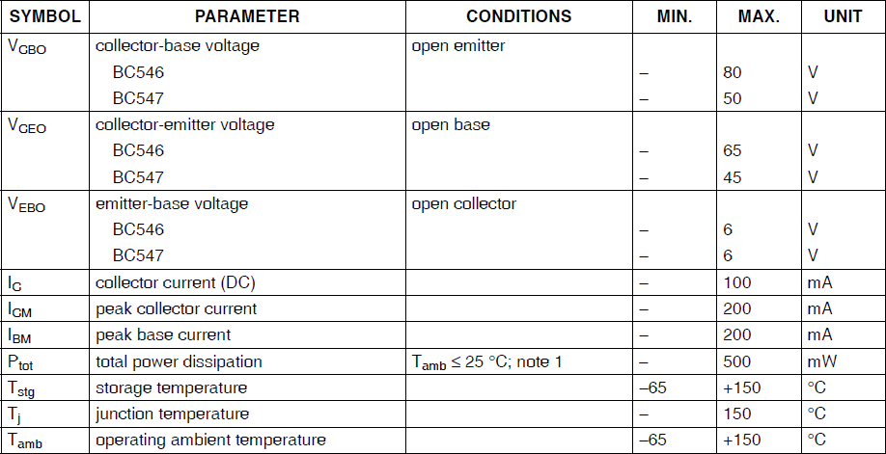

**Working of Common Emitter Amplifier:**

As the transistor has three terminals, one of the terminals is made common between input and output side and three configurations viz. CE, CB and CC are possible. Out of these, CE

configuration is widely used for amplifier circuits. This configuration provides high voltage gain and current gain as compared to other configurations. All types of transistor amplifiers operate using AC signal inputs which alternate between a positive value and a negative value so some way of "pre-setting" the amplifier circuit to operate between these two maximum or peak values is required. This is achieved using a process known as biasing. Biasing is very important in amplifier design as it establishes the correct operating point of the transistor amplifier ready to receive signals, thereby reducing any distortion to the output signal. Transistor should be biased in the active region when used as an amplifier. Emitter-base junction is forward biased and collector-base junction is reverse biased. The single stage common emitter amplifier circuit shown in Fig. 4.2 uses what is commonly called ‘Voltage Divider Biasing’. This type of biasing arrangement uses two resistors as a potential divider network across the supply with their centre point supplying the required base bias voltage to the transistor. Voltage divider biasing is commonly used in the design of bipolar transistor amplifier circuits. This method of biasing the transistor greatly reduces the effects of variation in transistor parameters. The quiescent base voltage (*Vb*) is determined by the potential divider network formed by the two resistors, *R1*, *R2* and the power supply voltage *Vcc* as shown in Fig.

* 1. The voltage level generated at the junction of resistors *R1* and *R2* holds the base voltage (*Vb*) constant at a value below the supply voltage. Then the potential divider network used in the common emitter amplifier circuit divides the input signal in proportion to the resistance. This bias reference voltage can be easily calculated using the simple voltage divider formula below:

(4.1)

(4.2)

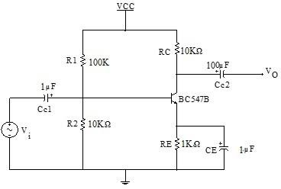

**Fig 4.2: Circuit diagram of CE Amplifier**

The supply voltage (*VCC*) also determines the maximum Collector current, *IC* when the transistor is switched fully ‘ON’ (saturation), *VCE* = 0. The Base current *IB* for the transistor is found from the collector current, *IC* and the DC current gain beta, *β* of the transistor. β is sometimes referred to as *hFE* which is the transistors forward current gain in the common emitter configuration. It has no units as it is a fixed ratio of the two currents, *IC* and *IB*. So a small change in the base current will cause a large change in the collector current. As the

base-emitter junction is forward-biased, there will be a difference of 0.7 V between the base and emitter.

**Coupling Capacitors:**

In Common Emitter Amplifier circuits, capacitors *CC1* and *CC2* are used as coupling capacitors to separate the AC signals from the DC biasing voltage. This ensures that the bias condition set up for the circuit to operate correctly is not affected by an additional amplifier stages, as the capacitors will only pass AC signals and block any DC component. The output AC signal is then superimposed on the biasing of the following stages. The emitter bypass capacitor, *CE* is connected between the emitter and ground of the transistor circuit. This capacitor is an open circuit component for DC bias meaning that the biasing currents and voltages are not affected by the addition of the capacitor maintaining a good Q-point stability. However, this bypass capacitor short circuits the emitter resistor a high frequency signals and only *RL* plus a very small internal resistance acts as the transistors load increasing the voltage gain to its maximum.

**Amplification Process:**

When a sinusoidal input signal is applied at the input terminals of the circuit during positive half cycle, the forward bias of base emitter junction (*Vbe*) is increased resulting in an increase in the base current (*Ib*), as a result collector current *Ic* increases due to which the output voltage *Vce* decreases. Thus in a CE amplifier a positive going input signal is converted to a negative going output signal i.e, a 180° phase shift is introduced between the input and output and is an amplified version of input signal.

**Voltage Amplifier Gain:**

Voltage Gain (Av) = Output Voltage / Input Voltage = *Vout* / *Vin* (4.3)

# Procedure:

* + 1. Set up the circuit as per the circuit diagram shown in Fig. 4.2.
    2. Apply the supply voltage, *VCC* = 10 V.
    3. Apply ac input signal of 2V, 100 Hz frequency at the input of the amplifier from function generator.
    4. Observe the output signal on the CRO and calculate *Vout*.
    5. Calculate the gain of the amplifier using the relation Gain = .
    6. Record the readings in the observation table by varying V*in* from 2V to 5V.
    7. Draw the input and output voltage waveforms.

# Observation Table:

|  |  |  |
| --- | --- | --- |
| **Input (*Vin*)** | **Output (*Vout*)** | **Gain (*Vout*/*Vin*)** |
| 40mV | 5.00 Vx1V | 12.5 V |
| 50mV | 6.5 V x1V | 13 V |
| 60mv | 7.8 V x 1V | 13 V |
| 70mv | 4.5V x2V=9.0V | 12.8 V |
| 80mv | 5.0V x 2V =10 V | 12.5 V |

**Note: Students are instructed to do all the necessary calculations on separate sheets.**

# Conclusion:

# Thus we have designed and assembled a common emitter transistor amplifier circuit and found that the average value of β (voltage amplification factor) for the given circuit is 5.438 as well as the input and output waveforms of the single

# stage CE amplifier circuit which we found to be at a phase relation of 180

# degree (inverted wave output).

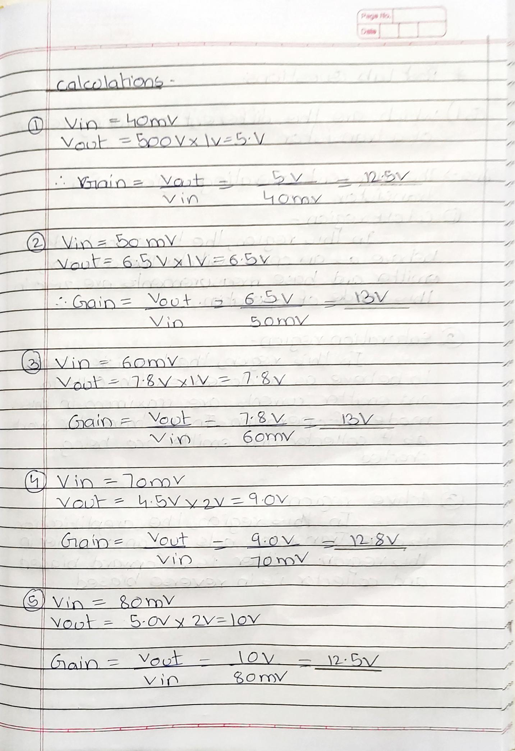

**BJT as Amplifier:**

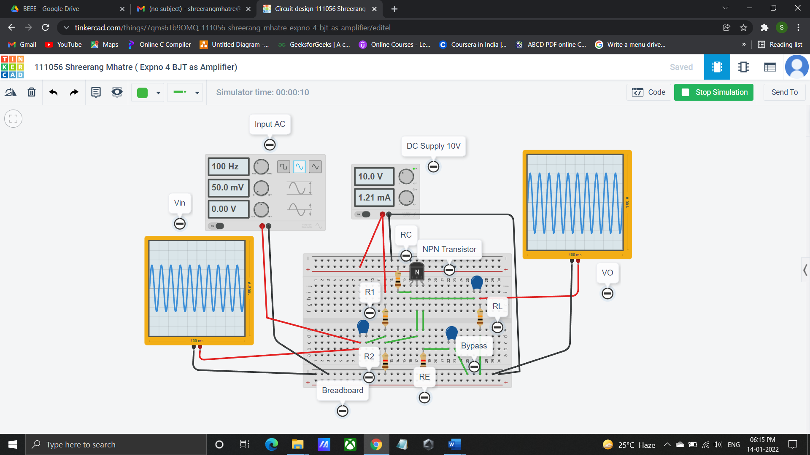



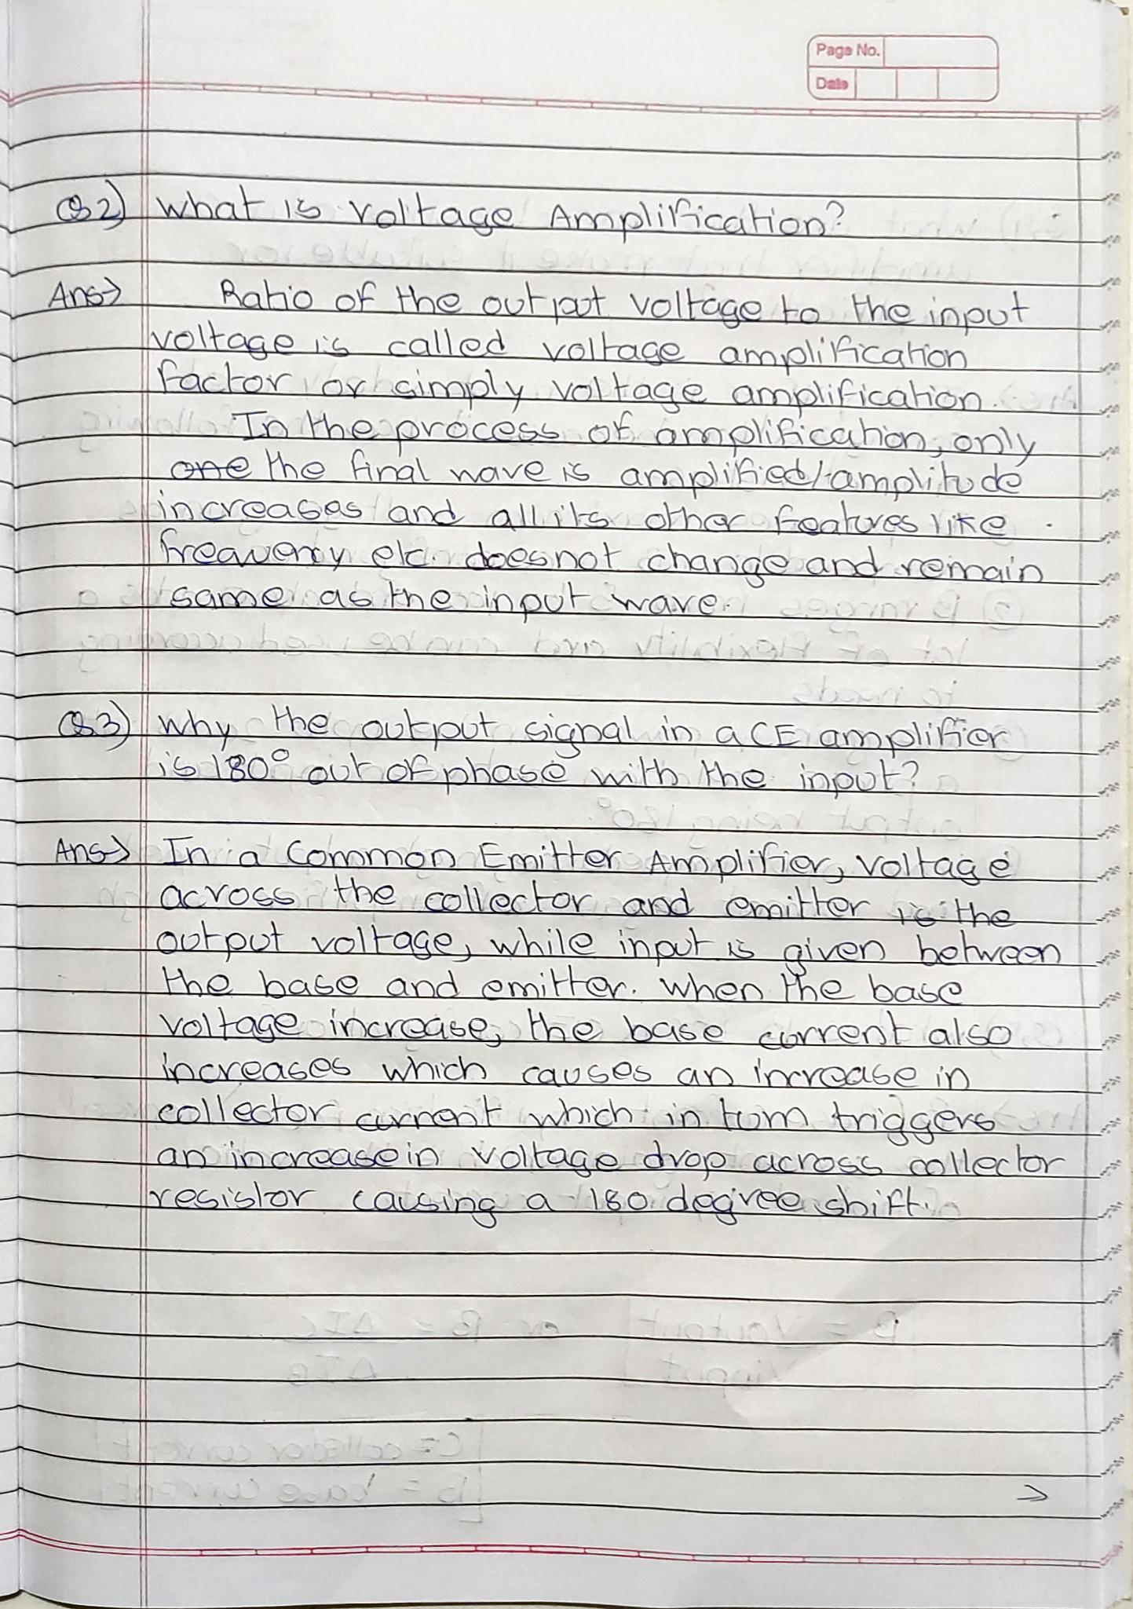

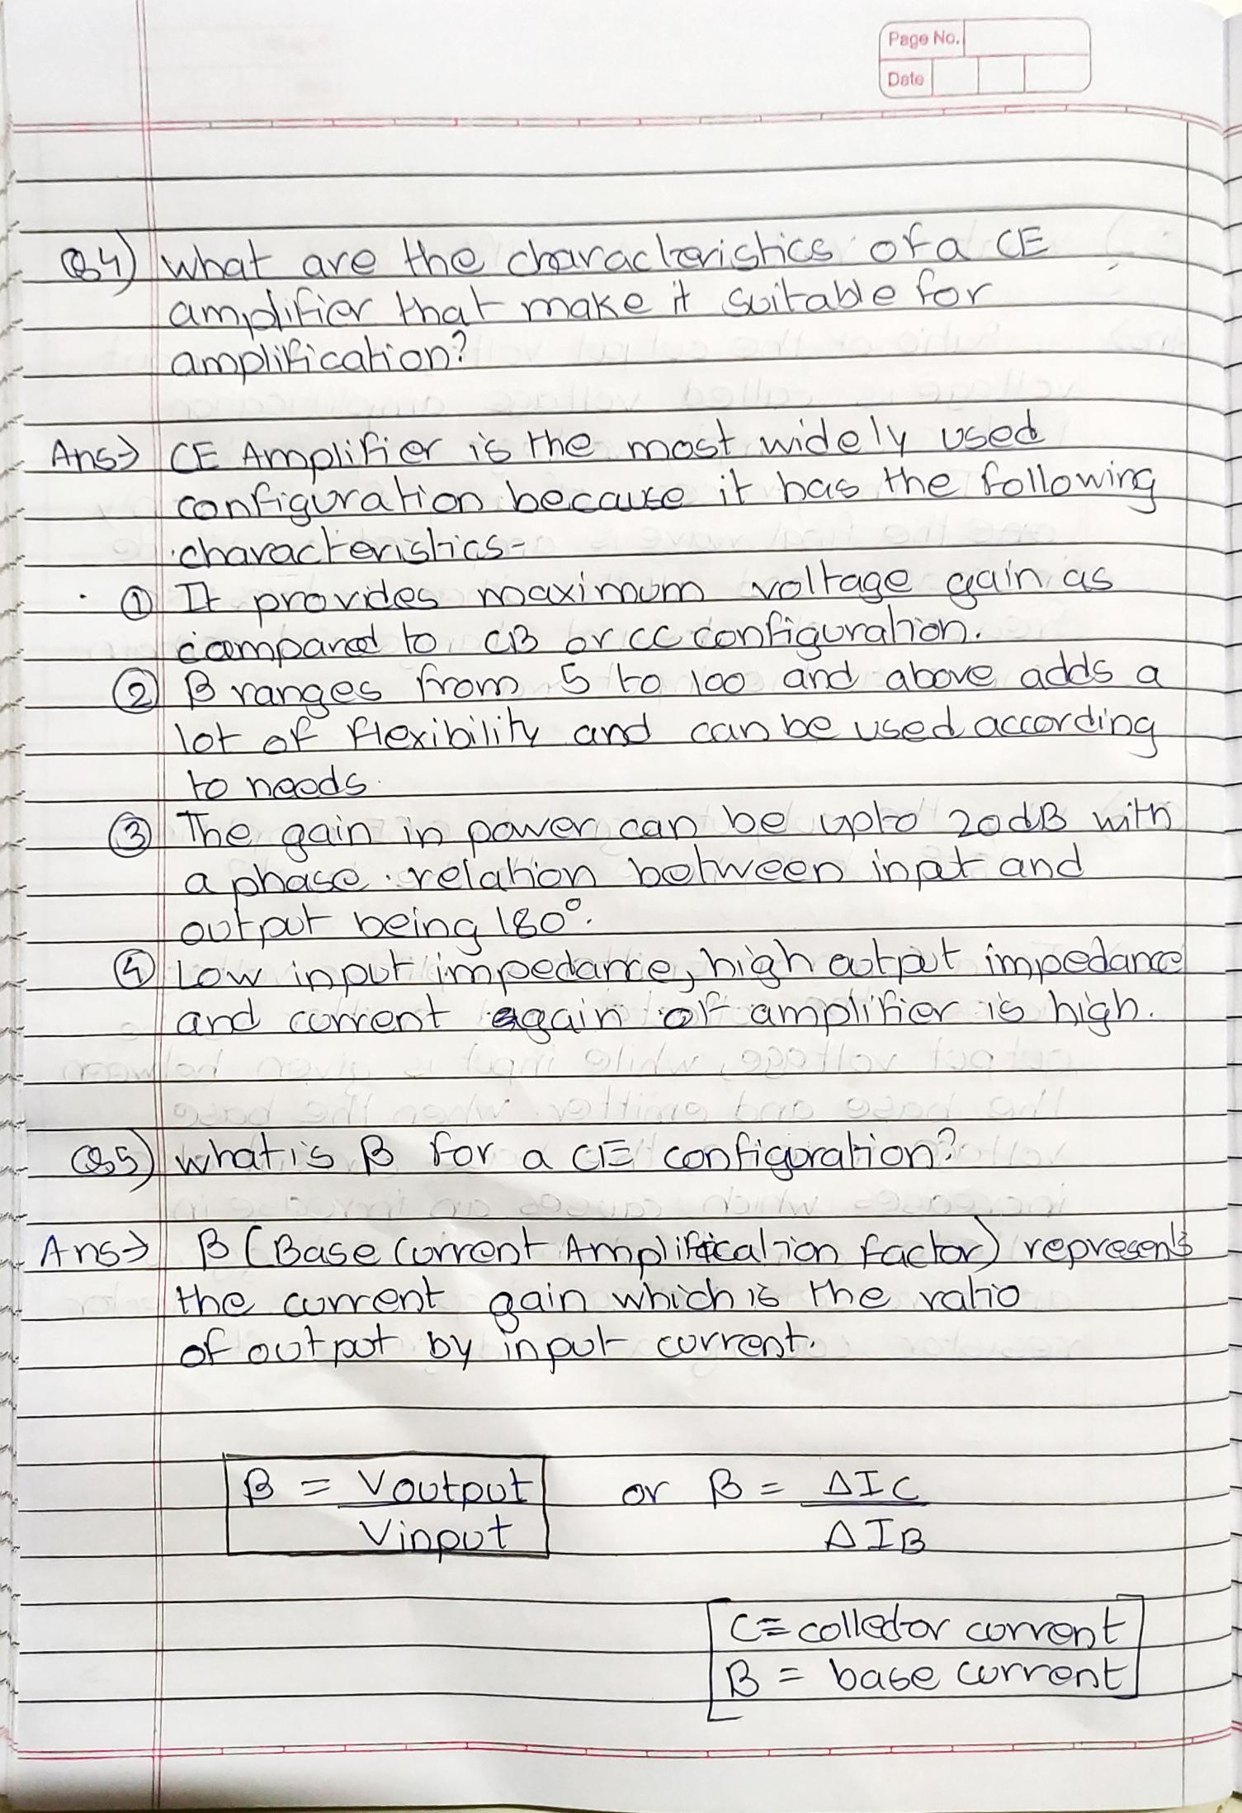

**Post Lab Questions:**

* + - 1. Which are the different operating regions of a transistor?
      2. What is Voltage Amplification?
      3. Why the output signal in a CE amplifier is 180°out of phase with the input?
      4. What are the characteristics of a CE amplifier that make it suitable for amplification?
      5. What is *β* for a CE configuration?

# Additional links for more information:

* <http://www.buildcircuit.com/darklight-sensor-using-transistor/>

